ECON 152, Winter 2020
Practice Questions for First Written Exam

In our basic model of piece rates, we found that a 100% piece rate was the socially optimal policy under a fairly wide variety of conditions. For each of the following assumptions in the basic model, state whether relaxing the assumption (with no other changes to the model) typically causes the optimal piece rate to deviate from 100%.

a linear production function, Q(E).
We assume in our model that an agent’s output is a function of their effort and is either one for one such that one unit of effort provides one unit of output or is moderated by a productivity parameter ‘d’. We know that there are often diminishing marginal returns to effort in reality and so a linear production function may not be realistic. However, if we relax this assumption so that production is quasi-linear or exponential, our optimal piece rate will still equal 100% as long as the function is increasing.

a quadratic cost-of-effort function, V(E)
Cost of effort V(E) does not need to be a quadratic function. All that matters is that the agent’s cost of effort is increasing, and eventually increasing at an increasing rate. What I mean by that is it takes more effort (it’s more costly) to produce one unit of output at the end of the day in hour number 8 compared to the first hour on the clock.

no uncertainty in production
Up to this point, we have assumed that there are no other variables affecting our agent’s output other than the amount of effort they choose. Nothing changes when we introduce uncertainty as long as our agent is risk neutral.

the agent is risk neutral

Briefly describe the optimal piece rate contract in a situation where the agent’s production is subject to uncertainty, the agent is risk averse, and the contract can depend on the state of nature
Risk aversion in a sense measures how much an agent values a guaranteed payment in the face of uncertainty. A risk averse agent presented with a situation where an external factor outside of their control impacts their output, and corresponding level of income, faces an important trade-off between insurance (base pay) and incentives (expected commission income). They must choose between a higher level of base pay and low commission rate or lower base and higher commission rate.
Imagine the people working at fruit stands on the side of the ride. Their sales are highly correlated to the amount of traffic driving by on any given day and let’s say that traffic fluctuates depending on the weather – i.e. people stay inside when it rains so therefore, they have fewer possible opportunities to sell fruit. If they are risk averse and the external factor, in this case rain, is measurable, the optimal piece rate doesn’t deviate from 100%. However, since their alternate utility is fixed, they may demand a higher guaranteed base payment (a) in the bad state to make up for fewer sales despite the same amount of effort.

Briefly describe the optimal piece rate contract in a situation where the agent’s production is subject to uncertainty, the agent is risk averse, and the contract cannot depend on the state of nature.

HRM and pay policies can affect both the motivation of a company’s existing workers and the types of workers who eventually self-select into and out of the company. Describe the econometric approach that Lazear used to separate these two effects of the PPP plan. Which channel turned out to be more important in the PPP case?

Using a diagram, show why we expect safelite’s PPP plan to increase the variance of output across workers
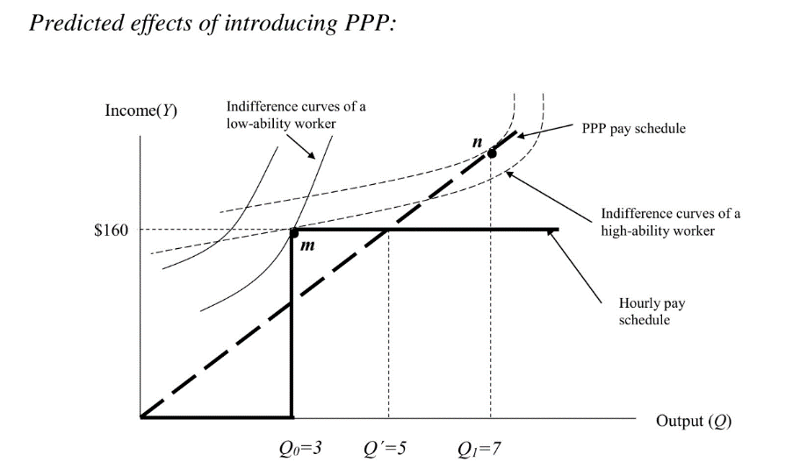
Before Safelite introduced their performance pay plan (PPP), no financial incentives were provided for additional output beyond Q₀ and we expected both low- and high-ability workers to produce Q₀. When PPP becomes available, we expect high-ability workers to raise their output to Q₁, but low ability workers to stay at Q₀ for one of two reasons: (1) it takes too much effort for them to complete the number of units where the pay-per-unit plan provides more income or; (2) they are so bad at their job that they couldn’t finish more than the five units required to breakeven in terms of pay under either plan (hourly or pay-per-unit) even if they tried. So, unless all of the bad employees quit and the new PPP motivates more skilled workers to join Safelite’s team, we would expect to see the variance of output increase across workers.

Did the typical participant in gneezy and rustichini’s (2000) experiment study of piece rates expect that low piece rates would elicit lower effort than a zero piece rate? Explain how the authors know what these expectations were.
Yeah, 100%. According to standard economic reasoning, an increase in the financial incentives provided for an activity will improve performance. This prediction is a conclusion of very basic assumptions in economic theory: performance is positively related to effort; effort is unpleasant, and money is good.
However, Gneezy and Rustichini’s study suggests that the effects of monetary incentives can be, for small amounts, detrimental to performance. The subjects in the experiment were students in the role of principals who were promised a payment proportional to the performance of a different person (their “agent”), and they had to choose the incentive scheme for the agent. Of the 53 principals in the experiment, 87 percent chose to pay the agent 10 cents for every correct answer. This choice reduced their income in two ways: by providing a payment to the agent, and by reducing the performance of the agent because of the native effect of low rewards. The group which received no payment for every correct answer averaged 28.4 correct, whereas the group which received 10 cents only averaged 23.07 correct.
The standard economic theory fails because factors different from money and effort may enter into the decision of the agent. For instance, a person may be reluctant to work for very small compensation because this fact might signal their general willingness to accept a small wage, and thus weaken their future bargaining position. A different reason is that people follow social norms that prescribe a behavior independently of any monetary compensation.
Behavioral psychologists suggest an activity has a motivation of its own, independent of any reward, called intrinsic motivation. The main conclusions of these experiments were that positive rewards, in particular monetary rewards, have a negative effect on intrinsic motivation.

In their “Legos” experiment, ariely et al. were able to estimate that the intrinsic value of ‘meaningful’ work had a motivation effect equivalent to a 39 percent wage increase. describe how they were able to come up with this number.
  - Man’s Search for Meaning: The case of Legos, page 9
Ariely and his team recruited two groups of Harvard undergraduates to assemble Lego sets. These participants received $2.00 for the first set they did and $0.11 less for each subsequent set, so that they were paid $0.02 for the 20th set. Group A got to keep their completed sets of Legos in front of them while they continued to work while Group B was placed in the Sisyphus condition. They found that the average worker in Group A completed somewhere around 10.6 sets compared to the average worker in Group B who only did 7. They illustrate the reward schedule and the two group’s cost of effort function graphically so that the point at which the lines intersect shows each group’s reservation wage. They found that the median subject in Group B stopped working at $1.40, while the median subject in Group A stopped at $1.01. This is statistically significant as the Sisyphus condition increased the median reservation wage by about 40 percent.

What is the 2D:4D ratio? How does it relate to the effects of high stakes on worker performance?
The 2D:4D ratio measures the length of someone’s pointer and ring fingers. Low 2D:4D is associated with high pre-natal androgen exposure, which is linked to high performance in competitive sports and higher risk preferences. Coates et al found that an extremely high share of noise traders in London have a low 2D:4D ratio. Those with a low 2D:4D also last longer in the profession and make more money.
The main lesson is that you can’t study the behavior of a ‘representative sample of the population’ and generalize about a pool of workers who have chosen a certain kind of work. In other words, looking at motivation without also considering selection can be misleading.

Mira has a three-day workweek, consisting of days t = 0, 1 and 2. Her production function each day is Q_{t}=E_{t}, and her disutility of effort function is V(E_{t}) = E₂. At the end of the week (on day 2), she is paid what she produced during the entire week: Y₂ = Q₀ + Q₁ + Q₂. She is not paid on any other days.
  - Mira is present-biased with β-δ preferences, so her preferred effort plan for the week when
  - viewed from the perspective of period 0 solves: Max (E₀, E₁, E₂) U₀ + βδU₁ + βδ²U₂
  - For β =.5 and δ= .8, derive Mira’s preferred (current and future) effort plan from the point of view of period 0 and from the point of view of period 1. Do these differ? Explain why or why not.

Psychologists describe the relationship between rewards and task performance using the concepts of motivation and arousal.

Define these two concepts.

Motivation: Explains a persons willingness to exert effort in order to complete a goal or set aim.
Intrinsic Motivation: A specific activity with an incentive to engage and is derived from the activity itself (e.g. a genuine interest in a studied subject) rather than because of benefits that are external and might be obtained
Extrinsic Motivation: Extrinsic motivation explains the drive for an individual to participate within a specific activity or role given the potential to achieve a reward or punishment.

Arousal: A state of alertness and readiness for action – (not explicitly defined by Ariely et al.)

According to psychology’s Yerkes Dodson law, what is the shape of the relationship between arousal and task performance?
The relationship between arousal and task performance looks hump shaped. Yerkes-Dodson Law implies that there is an optimal level of arousal for executing tasks, and that deviations in either direction will hurt performance. People perform better on tasks at moderate levels of arousal compared to no arousal, but their performance suffers at higher levels. This theory helps explain why people choke in high pressure situations.
https://www.verywellmind.com/the-arousal-theory-of-motivation-2795380

In their experiment on Indian villagers, how do ariely et al. (2009) use this paradigm to explain the fact that high financial incentives reduced the villagers’ performance?
Ariely et al. recruited Indian villagers to participate in six games that required creativity, memory, or motor skills. The villagers were randomly grouped and assigned a low, medium, or high-level financial incentives based on their performance. What the researchers found was that performance is superior for moderate incentives relative to very high incentives. Their results suggest that an over motivated principal might hire an agent to perform a task at a more optimal, reduced level of incentives.

Discuss the two main costs associated with using commitment contracts with penalties for below-target outputs to solve self-control problems in the workplace

Describe two experiments – one in the lab and one in the field – that illustrate the phenomenon of loss aversion with respect to a reference point

Summarize three main empirical results of kaur et al.’s study of data-entry workers in India
  - Self-control at work, page 4
- Workers work harder as the payday gets closer. They earn 8% more on paydays than at the beginning of the weekly pay cycle. This is not concentrated on the payday: production rises smoothly through pay cycle
- Dominated contracts are chosen on 35% of the workers days where they are offered. The ability to choose a dominated contract increases productivity.
- These two effects are related.

Multi-task principal-agent problems

What does it mean for two tasks to be complements to the principal? What does it mean for two tasks to be substitutes to the principal? In which of these two situations will the multi-task principal-agent problem be most severe? Why?

Complements***: Strongly prefer Agent to do some of each task, versus doing only one or the other
***Efficiency costs will be most sensitive to partial financial incentives

Substitutes: Roughly indifferent as to how the agent allocates his effort across the tasks

What does it mean for two tasks to be complements to the agent? what does it mean for two tasks to be substitutes to the agent? In which of these two situations will the multi-task principal-agent problem be most severe? Why?

Complements: Strongly prefer to perform some of each task to doing only one or the other

Substitutes***: Doesn’t care too much which one he performs (if he’s at work anyway)
***Efficiency costs will be most sensitive to partial financial incentives

Describe how job design can be used to mitigate multi-task principal agent problems in an organization. aside from addressing multi-task incentives, what other organizational goals might be important to keep in mind when changing job design?
When a principal employs an agent to perform multiple tasks but uses incomplete incentives, we expect agents to re-allocate their effort towards the incentivized (and easy-to-observe) tasks and away from the non-incentivized (and hard-to-observe) tasks.
Principals can design jobs based on the observability of the tasks the employee is expected to perform and set financial incentives for each job accordingly. Efficiency costs are limited by narrowing an agent’s focus. Other organizational goals to keep in mind include employee discretion and input-related measures (i.e. work hours), intrinsic motivation and desires to shirk.
Easy-to-observe: Strong financial incentives ($b≅1$) – employee discretion can be high – selecting for applicants with high intrinsic motivation and low desires to shirk is less important because their income depends on effort
Hard-to-observe: Weak financial incentives ($b≅0$) – employees should be given less discretion about work hours and other input-related measures – careful screening to identify applicants with high intrinsic motivation and low desires to shirk is important.

True or false: Convex reward schedules, R(Q), incentivize agents to change the timing of recorded output to be as constant as possible over time. Explain your answer
False: Convex reward schedules increase at an increasing rate (such that R’(Q) > 0 and R’’(Q) > 0). The amount of commission a salesperson earns per deal increases as they close more deals. Agents maximize their utility and income by producing an uneven, or highly variable, level of output.
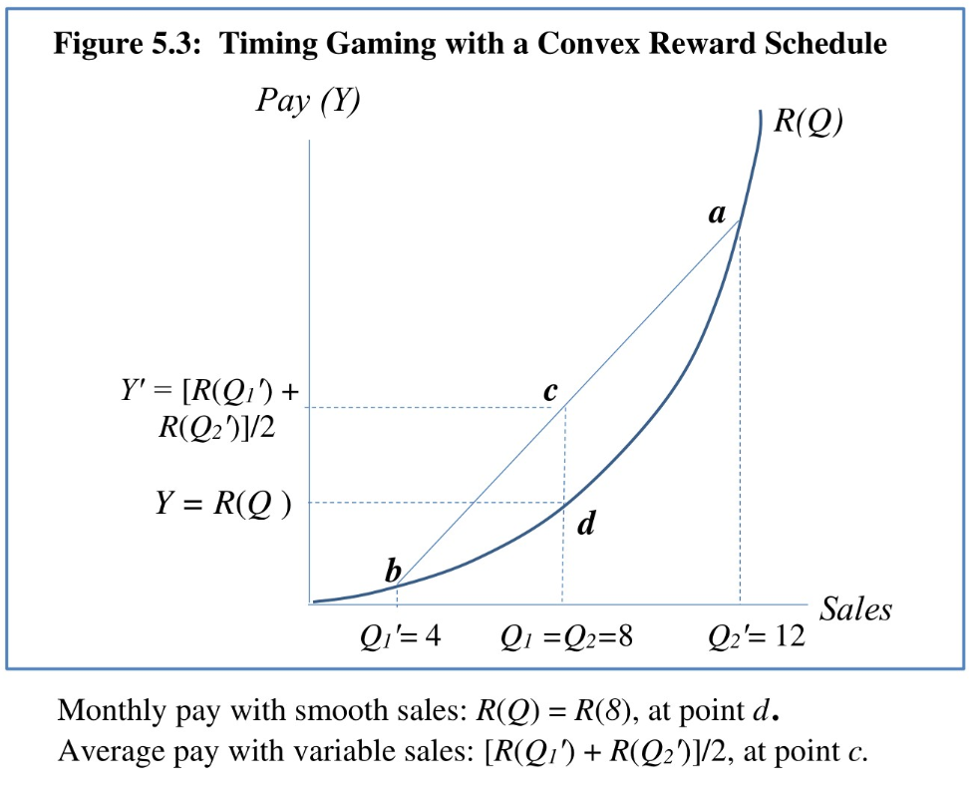
Consider the following: It’s the last day of the quarter and you’ve sold 35 units. Your customer Joe wants to make a deal for 40 units next quarter and another customer John just called to see if you have something in stock. Under a convex reward schedule, the amount of commission income you earn on sale #41 is higher than #36 and so, slow playing John to close the sale next month is the winning strategy if you’re acting purely in self-interest and trying to maximize your commission income.

Imagine you are a car salesperson with a bonus contract that pays you $2000 in a month if you sell less than eight cars, and $3000 if you sell eight or more. If you expect to sell six this month and ten next month, discuss how you can game this system to raise your average monthly pay from $2500 to $3000. Illustrate using a diagram.
You could offer a deep discount to pull two sales originally expected to close next month forward to this period.
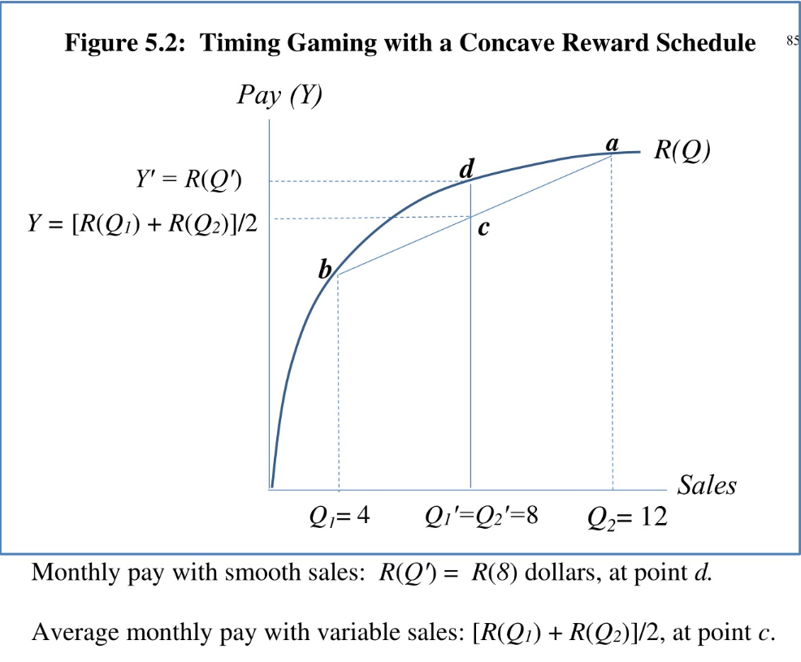

Briefly describe three empirical studies of timing gaming

Benson’s (2015) study of timing gaming showed that sales managers (who did not engage in sales themselves) were able to manipulate the sales of their subordinates to maximize their own bonuses. Describe how these sales managers accomplished this.
- Reduce the quotas of salespeople who were far below their targets to increase motivation: Lowering the target might encourage a salesperson who had given up on achieving their quota to make a last push towards the finish line
- Retain underperforming salespeople: Letting someone continue to underperform is easier and results in more sales in the short run. The manager would miss out on sales this period by hiring someone new and firing the underperformer due to the amount of time it takes the new hire to ‘ramp-up’ and start closing deals.

Alfredo and Betty are talking today about the relative value they place on utility they would experience on four different days: Today (t= 0), tomorrow (t=1), one week from today (t=7), and one week plus one day from today (t=8)
  - Alfredo values utility tomorrow (t=1) 50 percent as much as utility today (t=0). While he cares even less about utility one week from today (on t=7), he feels the same way about t=8 compared to t=7: he values utility on day 8 only 50 percent as much as utility on day 7.
  - Betty values utility tomorrow (t=1) 70 percent as much as utility today (t=0). While she cares even less about utility one week from today (on t=7), she feels differently about t=8 compared to t=7: She values utility on day 8 only 80 percent as much as utility on day 7.
  - Which of these two people, if any, have present-biased preferences? Which one(s) will exhibit time-inconsistent choice behavior? Explain your answers.

